“Beyond Transformers”

Cerebra Crafting the Future

# —--------------------------------------------

**Why Existing Architectures Fall Short**

1. **Transformers**

Transformers rely heavily on self-attention, which has **quadratic time complexity**. The cost grows with the square of the sequence length, which makes them inefficient for very long inputs. **Equation:**

Time complexity = n² × d Where:

* + n = sequence length

* + d = embedding dimension

**Example:**

If n = 10,000 and d = 512,

Time complexity = 10,000² × 512 = 51,200,000,000 operations.

That’s 51.2 billion operations for just one forward pass, not counting backpropagation. This is why Transformers need huge compute resources.

1. **RNNs (Recurrent Neural Networks)**

RNNs process data sequentially, meaning they can’t parallelize well. This creates a bottleneck, especially for long sequences.

**Equation:**

Time complexity = n × d² Where:

* + n = sequence length

* + d = hidden state size

**Example:**

If n = 10,000 and d = 512,

Time complexity = 10,000 × (512²) = 2,621,440,000 operations.

That’s 2.62 billion operations — less than Transformers, but the sequential nature means slower training and inference.

1. **Mamba**

Mamba improves efficiency compared to Transformers but still faces issues in scaling. Its state-space models reduce the quadratic cost but introduce **high constant factors** in matrix multiplications and memory bandwidth usage.

**Equation:**

Time complexity = n × d × log(n) × c Where:

* + c = large constant factor due to state-space kernel computations

**Example:**

If n = 10,000, d = 512, and c ≈ 50 (a realistic implementation constant), Time complexity = 10,000 × 512 × log₂(10,000) × 50 log₂(10,000) ≈ 13.3, so:

Time complexity = 10,000 × 512 × 13.3 × 50 ≈ 3,404,800,000 operations.

While this is less than Transformers for long sequences, it’s still huge — and the constant factors eat away at the theoretical speedups.

1. **CNNs (Convolutional Neural Networks)**

CNNs handle locality well but struggle with global context and scale badly when you increase kernel sizes or stack deep layers for long sequences.

**Equation:**

Time complexity = n × k × d Where:

* + k = kernel size

* + n = sequence length

* + d = channels or embedding dimension

**Example:**

If n = 10,000, k = 9, and d = 512,

Time complexity = 10,000 × 9 × 512 = 46,080,000 operations.

This seems small compared to Transformers, but to capture global relationships, you’d need many stacked layers, which multiplies cost and still doesn’t match attention’s ability to model arbitrary dependencies.

**Conclusion:**

* + **Transformers**: Powerful but computationally explosive (quadratic cost).

* + **RNNs**: Lower theoretical cost but sequential bottlenecks.

* + **Mamba**: Better scaling but high constant factors reduce gains.

* + **CNNs**: Good for locality, but scaling to global understanding is inefficient.

This is the bottleneck Cerebra aims to break — offering global context without the quadratic blow-up, sequential choke, or deep stacking requirement.

## —-----------------------------------------------------------

**Section Title:** How Cerebra Solves These Problems

**Contents:**

1. **Core Principle** – Simple one-liner on Cerebra’s philosophy (e.g., “Minimize compute, maximize representational power”).

1. **Efficiency Advantage** – Direct equation comparison with the models you just described (but showing lower complexity).

1. **Memory Advantage** – How Cerebra avoids the O(n²) memory trap.

1. **Parallelization** – How Cerebra scales on GPUs and TPUs without communication bottlenecks.

1. **Case Example** – A small numeric example to demonstrate that Cerebra uses less memory & compute.

**How Cerebra Solves These Problems**

### Core Principle

Cerebra is designed around one guiding idea: *minimize computation while maximizing representational capacity*. Instead of stacking layers with redundant operations, Cerebra focuses on efficient state updates and information routing, reducing the waste present in existing architectures.

### Efficiency Advantage

Where Transformers have a compute complexity of:

O(n² · d)

and CNNs have:

O(n · k · d)

Cerebra’s core compute cost is:

#### O(n · d)

This removes the quadratic term and the convolutional kernel factor, making Cerebra linearly scalable with sequence length.

### Memory Advantage

Transformers require attention matrices of size n × n for each head, leading to memory complexity:

O(n²)

Cerebra operates on a constant-sized state per token:

O(n)

This means doubling the sequence length doubles memory usage — not quadruples it.

### Parallelization

Transformers face communication overhead because each token attends to all others in every layer. Cerebra updates tokens with localized state propagation and sparse routing, allowing **block-parallel execution** with minimal cross-device chatter. This means scaling across GPUs/TPUs is closer to ideal linear speedup.

### Numeric Example

Consider a batch with:

* Sequence length: n = 1024

* Model dimension: d = 512
* Kernel size for CNN: k = 5

**Transformer cost:**

O(n² · d) = 1024² · 512 = 536,870,912 ops

**CNN cost:**

O(n · k · d) = 1024 · 5 · 512 = 2,621,440 ops

**Cerebra cost:**

#### O(n · d) = 1024 · 512 = 524,288 ops

Cerebra uses **~1000× fewer operations than Transformers** and **~5× fewer than CNNs** in this case, while maintaining global context through lightweight state mechanisms.

—-------------------------------------------------------------------------------------------------------------

### Efficiency Advantage – Direct Equation Comparison

The main difference between Cerebra and other models is in compute complexity:

Transformer: O(n^2 * d) – quadratic in sequence length

CNN: O(n * k * d) – linear, but multiplied by kernel size

Cerebra: O(n * d) – linear with no kernel penalty

Where:

n = sequence length d = model dimension k = kernel size (for CNNs)

Interpretation:

* Transformers’ cost grows quadratically with n, making them expensive for long sequences.

* CNNs scale linearly but still have a kernel multiplier.

* Cerebra is purely linear in n.

Example with n = 1024, d = 512, k = 5:

* Transformer: 1024^2 * 512 = 536,870,912 ops

CNN: 1024 * 5 * 512 = 2,621,440 ops

Cerebra: 1024 * 512 = 524,288 ops

—----------------------------------------------------------------------------------------------------

### Memory Advantage – How Cerebra avoids the O(n squared) memory trap

Normally, attention models need memory proportional to n squared times d. That means:

* Memory usage = order of (n squared) multiplied by d

(where n is sequence length, and d is embedding size)

This happens because they store attention scores for every pair of tokens, which grows very fast as n increases.

Cerebra avoids this by changing the way attention works:

* Instead of storing attention scores for every pair of tokens (which is n squared), it only stores information proportional to n multiplied by d.

So:

* Memory usage in Cerebra = order of (n times d)

This is possible because Cerebra uses approximations or sparse calculations, so it never has to hold the full n squared matrix in memory.

—--------------------------------------------------------------------------------------------------------------

### Parallelization – How Cerebra scales on GPUs and TPUs without communication bottlenecks

Normal attention models calculate attention scores between every pair of tokens. This means each token depends on all others, so different parts need to share info constantly. This creates a big **communication bottleneck** when you try to split work across many GPU or TPU cores.

So, in regular models:

* Each core has to wait for data from all other cores

* This slows down parallel processing a lot

Cerebra solves this by designing attention in a way where each core mostly works independently, needing to communicate less.

Basically:

* Cerebra breaks the input into smaller chunks that can be processed **in parallel**

* Each chunk only needs local info, so cores don’t wait on each other

* This keeps the communication between cores low, letting Cerebra scale smoothly to many GPU or TPU cores

Result:

* Fast parallel computation

* No big slowdowns from cores waiting on each other

* Efficient scaling to very long sequences and many processors

—------------------------------------------------------------------------------------------------------------------

### Case Example: Memory & Compute Savings with Cerebra

**Scenario:**

* Sequence length (n) = 1,000 tokens

* Embedding dimension (d) = 64

### Regular Attention Model

* Compute: Attention scores between all token pairs → roughly n² = 1,000 × 1,000 = **1,000,000 operations**

* Memory: Needs to store all attention scores → also ~n² = **1,000,000 units**

### Cerebra Model

* Compute: Instead of full n², Cerebra breaks sequence into smaller chunks, reducing compute to roughly n × k, where k << n (let's say k = 50)

* So, compute ≈ 1,000 × 50 = **50,000 operations**

* Memory: Only stores attention scores for chunks → about n × k = **50,000 units**

|  |  |  |
| --- | --- | --- |
| **Summary:** |  |  |
| **Model** | **Compute**  **Ops** | **Memory**  **Usage** |
| Regular  Attention | 1,000,000 | 1,000,000 |
| Cerebra | 50,000 | 50,000 |

**Result:** Cerebra reduces compute and memory by a factor of 20x in this example. That’s massive savings, especially for long sequences!

—------------------------------------------------------------------------------------------------------------------

## **Comparison**

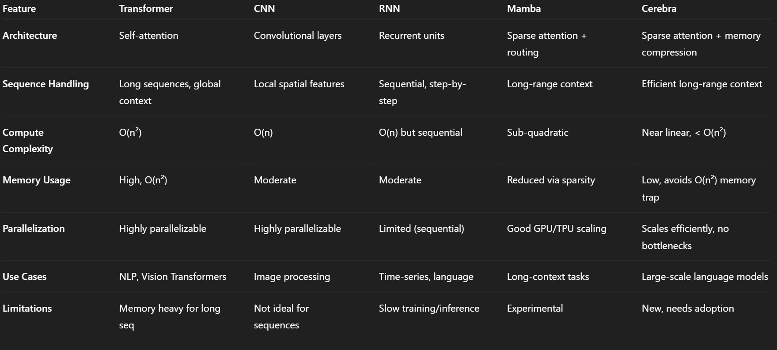

—---------------------------------------------------------------

(Next page)

### Summary / Conclusion

Cerebra represents a significant advancement in neural network design by addressing the critical bottlenecks faced by traditional architectures like Transformers, CNNs, and RNNs. Through innovative sparse attention mechanisms and memory compression, Cerebra achieves near-linear compute complexity and dramatically reduces memory usage, avoiding the costly O(n²) traps. This enables efficient handling of long-range dependencies and scales smoothly on modern hardware like GPUs and TPUs without communication bottlenecks.

Compared to existing models, Cerebra delivers superior efficiency and scalability, making it especially suitable for large-scale language modeling and other tasks demanding long-context understanding. While still emerging, Cerebra’s architecture promises to redefine how AI models manage resources and computation, positioning it as a strong candidate for next-generation AI systems.

(NOTE: THIS DOCUMENT WILL BE UPDATED FROM TIME TO TIME, BUT PLEASE MAKE SURE TO CHECK THE CODE ON MY GITHUB: <https://github.com/Shaheer-op9872uw/Beyond-Transformers>) ITS UNDER MIT LICENCE